}

Guide 1. APT Project Definition
Capstone Course

- PART I
1. Personal Details
The table below must be completed with the information requested.

Student name | Christian Soto, Gerald Silva, Kevin Herrera
National ID (RUT) | 19.170.096-1 - 19.222.490-k - 18664582-0
Program | Computer Engineering
Campus | Puente Alto

2. APT Project Description
In the description you must briefly state the name of your APT project and the graduate profile competencies you will put into practice. If performance areas are defined for your program, also mention which performance areas the project is linked to.

Project name | Data Fly Solutions (Workplace climate surveys)
Performance area(s) | Software Development, IT Architecture and Infrastructure, Database Management and Information Security
Competencies | State the competencies from your Study Plan that you will address in your APT Project.

3. APT Project Rationale
Below are various fields that must be completed with the information requested. This section asks you to describe your project in detail and justify its relevance and pertinence.

Relevance of the APT project | - Managing organisational climate is a critical factor for performance, talent retention and wellbeing in companies. However, many organisations face high costs with external consultancies or implement in-house tools that offer no real guarantees of confidentiality.  - This project sits within the context of SaaS software development in Chile, aimed at companies and institutions seeking to assess and improve their working environment efficiently. It has a direct impact on management and area heads, supporting decision-making based on concrete data, and on employees, giving them a secure and anonymous channel to express their perceptions.  - Its value lies in democratising access to a scalable multi-tenant web system that guarantees privacy from the database architecture upwards, incorporating analysis by area, structured emotion maps and market comparisons (benchmarking).
Description of the APT Project | The goal is to design, develop and implement a reusable multi-tenant (SaaS) web application for administering, managing and analysing workplace climate surveys. The system allows organisations to be managed within a single infrastructure isolated by security policies. It is approached through a decoupled architecture: an interactive frontend in React + TypeScript and a cloud backend using Supabase (PostgreSQL 17, Row Level Security and Edge Functions). Users sign in through passwordless authentication (magic link/OTP code via national ID and email), ensuring a smooth response process and guaranteeing that individual data remains anonymous by design at the database level.
Pertinence of the project to the graduate profile | The project relates directly to the Computer Engineer profile, since it practically integrates the four key areas of the program: software development, database management, information security and cloud architecture. The profile competencies are indispensable for solving the problem posed: implementing strict anonymity and multi-tenant architecture demands advanced command of relational modelling and access rules in PostgreSQL (RLS); the user experience requires sound modern web development practices (React/TypeScript); and going live demands managing infrastructure services and serverless automation
Relation to professional interests | My professional interest is focused on Full-stack software development, scalable cloud system architecture (SaaS) and the implementation of robust data security and privacy mechanisms.  This project directly reflects my professional goals by covering the full development cycle of a real digital product: from advanced relational modelling in PostgreSQL and Serverless logic development with Supabase Edge Functions, through to the design of modern, reactive interfaces with React and TypeScript. Completing it strengthens my technical profile in technologies in high demand across the industry, preparing me to lead technology projects from architecture through to commercial deployment.
Feasibility of developing the APT Project | - The project is entirely feasible to carry out within the academic framework for the following reasons:  1. Planning and time: The work plan fits the length of the academic semester and the weekly workload assigned to the course.  2. Resources and materials: Only personal computers and development infrastructure on Cloud services with free tiers are required, from Supabase (PostgreSQL, Auth, Edge Functions) and Vercel for hosting, removing financial cost barriers.  3. Enabling factors: The project has consolidated prior progress (database modelled with 11 migrations applied, initial repository and 28 functional requirements defined), in addition to the use of BaaS/Serverless technologies that speed up development without requiring complex server management.  4. Obstructing factors and mitigations:  • Database paused due to inactivity (Supabase Free): resolved by configuring an automated daily ping (keep-alive).  • Limits on bulk email sending: resolved by integrating an external transactional email service (Resend or SendGrid) ahead of launching real surveys.  • Corporate email filters that consume access links: mitigated through the implemented 6-digit OTP code flow, which is independent of the URL.

- PART II
4. Objectives
In this section you must define the general and specific objectives of the APT Project. It is important to note that objectives must be stated clearly and concisely and without further explanation, that is, they must be understandable on their own. It is suggested that they be written using a verb in the infinitive, as this forces you to specify concrete actions.

General objective | To develop and implement a multi-tenant web application for managing and analysing workplace climate surveys, guaranteeing the confidentiality and anonymity of employees through database security policies (RLS) and secure passwordless authentication.
Specific objectives | * To implement the multi-tenant architecture in Supabase (PostgreSQL 17) using Row Level Security (RLS) to isolate data by organisation and technically decouple the user's identity from their responses.  * To develop the web user interface using React, Vite and TypeScript, offering views tailored to the management, area head and employee roles.  * To create Serverless functions (Edge Functions) to process the access flow via magic link and OTP code, the sending of transactional emails and the calculation of aggregate metrics.  * To design and integrate analytical modules covering reports by dimension, emotion map by area, action plans and sector comparisons (benchmarking), applying anonymity thresholds to queries.  * To carry out functional, security and integration testing to validate compliance with the system's 28 functional requirements.

5. Methodology
In the following section you must describe the methodology specific to your discipline that you will use to deliver the APT project described above, including the stages and working methods.

Methodology Description
Methodology Description
The project is developed under an iterative and incremental agile methodology based on Scrum/Kanban, organised into short development cycles (Sprints) aimed at meeting the 28 defined functional requirements.
Project stages:
- Requirements Gathering and Architecture Design: Definition of requirements, design of interface mockups and structuring of the 11 database schema migrations in PostgreSQL.
- Backend and Security Layer Development: Configuration of the Supabase infrastructure, implementation of RLS access policies by role/company and creation of Edge Functions in TypeScript/Deno for the authentication and survey launch logic.
- Frontend Development and Integration: Construction of interactive components with React + Vite, integration with the database and development of role-specific views (Management, Area Head and Employee).
- Validation, anonymity and Testing: Execution of penetration and security testing at the RLS level, validation of the OTP authentication flow against corporate filters and client-server integration testing.
- Deployment and Go-Live: Publication of the application on Vercel, configuration of environment variables and connection to external transactional email services.
Definition of Roles and Responsibilities:
- Project Lead & Backend Developer (Christian Soto): Responsible for the cloud architecture, relational modelling in Supabase, configuration of RLS security policies and development of Edge Functions.
- Frontend Developer & UI/UX: Responsible for visual design, responsive layout, React component development and integration of user flows (login, survey response and analytics dashboards).
- DevOps & QA Engineer: In charge of the continuous deployment pipeline on Vercel, repository management, code quality verification and auditing of compliance with the anonymity rules.

6. Evidence
Below, describe what evidence will be assessed in the progress report and in the final report of your APT project. This evidence must be agreed with your teacher. Evidence is understood as the products developed during the project whose purpose is to make visible or document how the work has been carried out.

Type of evidence  (progress or final) | Name of the evidence | Description | Justification
progress | Architecture Document and Requirements Matrix | Technical documentation with the 28 functional requirements, the architecture diagram (React + Supabase) and the data dictionary corresponding to the 11 database migrations | Allows validation of the correct definition of scope, the non-negotiable architecture decisions and the relational schema design before the frontend is fully built.
progress | Code Repository and Backend/Security MVP | GitHub repository with the frontend structure initialised in React + TypeScript, SQL migrations applied in Supabase and RLS policies configured to guarantee multi-tenant isolation and anonymity. | Demonstrates initial technical progress, ensuring that the critical database security layer and access management are operational from the development phase onwards
Final | Deployed and Functional Web Platform | Fully operational multi-tenant web system deployed on Vercel, integrated with Supabase Edge Functions, a survey engine that preserves anonymity, login via code/magic link and analytics dashboards. | Constitutes the finished functional software product, evidencing compliance with 100% of the functional requirements in a real environment and ready for rollout.
Final | Final Report on Testing, Security and Manuals | Document consolidating the results of functional testing, the security audit at the RLS/anonymity level and the user manuals tailored to each role (Management, Area Head and Employee). | Certifies the quality, privacy and operational availability of the software, facilitating its handover, use by end users and future maintainability.

7. Work Plan
In the following table, define the plan for your APT Project as required.

APT Project Work Plan
Competency or units of competency | Name of Activities/Tasks | Description of Activities/Tasks | Resources | Duration of the activity | Person responsible | Comments
Database Management and Modelling / IT Architecture | Requirements Gathering, Architecture Design and Data Model | Analysis of the 28 functional requirements, multi-tenant relational modelling in Supabase (PostgreSQL 17) and structuring of the 11 initial schema migrations. | Personal computer, Supabase CLI, Node.js 24, VS Code | 3 weeks | Christian Soto | Enabler: Well-defined requirements matrix.  Difficulty: Designing the isolated multi-tenant schema in a single database without compromising performance..
Information Security / Solutions Development | Security, Authentication and RLS Policies | Implementation of Row Level Security (RLS) in Postgres, Auth Hooks for JWT claims and an authentication flow via national ID, Magic Link and a 6-digit OTP code. | Supabase Auth, Deno/TypeScript (Edge Functions), HTML email templates | 3 weeks | Kevin Herrea | Difficulty: Enabling hooks and redirection requires manual configuration in the Supabase dashboard.  Mitigation: Early testing with mocked JWT tokens
Software Solutions Development | Frontend Development and Survey Engine Integration | Construction of the web client in React + Vite + TypeScript, integration with the Supabase API and layout of the response module guaranteeing anonymity. | React, Vite, TypeScript, Tailwind CSS, Vercel. | 4 weeks | Kevin herrera/ gerald Silva | Enabler: Use of statically typed definitions auto-generated from the database (database.ts).  Difficulty: Dynamic handling of per-company branding from the login screen.

8. Gantt Chart
Find a Gantt Chart format that suits you and use it to organise the activities planned in the previous section, taking into account the period assigned for the development of your APT Project. You must keep to the timing of the academic period across the three phases covered by the Title Portfolio course.

Activity | Phase 1 |  |  |  | Phase 2 |  |  |  |  |  |  |  |  |  |  |  | Phase 3
Activity | W 1 | W 2 | W 3 | W 4 | W 5 | W 6 | W 7 | W 8 | W 9 | W 10 | W 11 | W 12 | W 13 | W 14 | W 15 | W 16 |  | W 17 | W 18
Describe the activities from the previous section
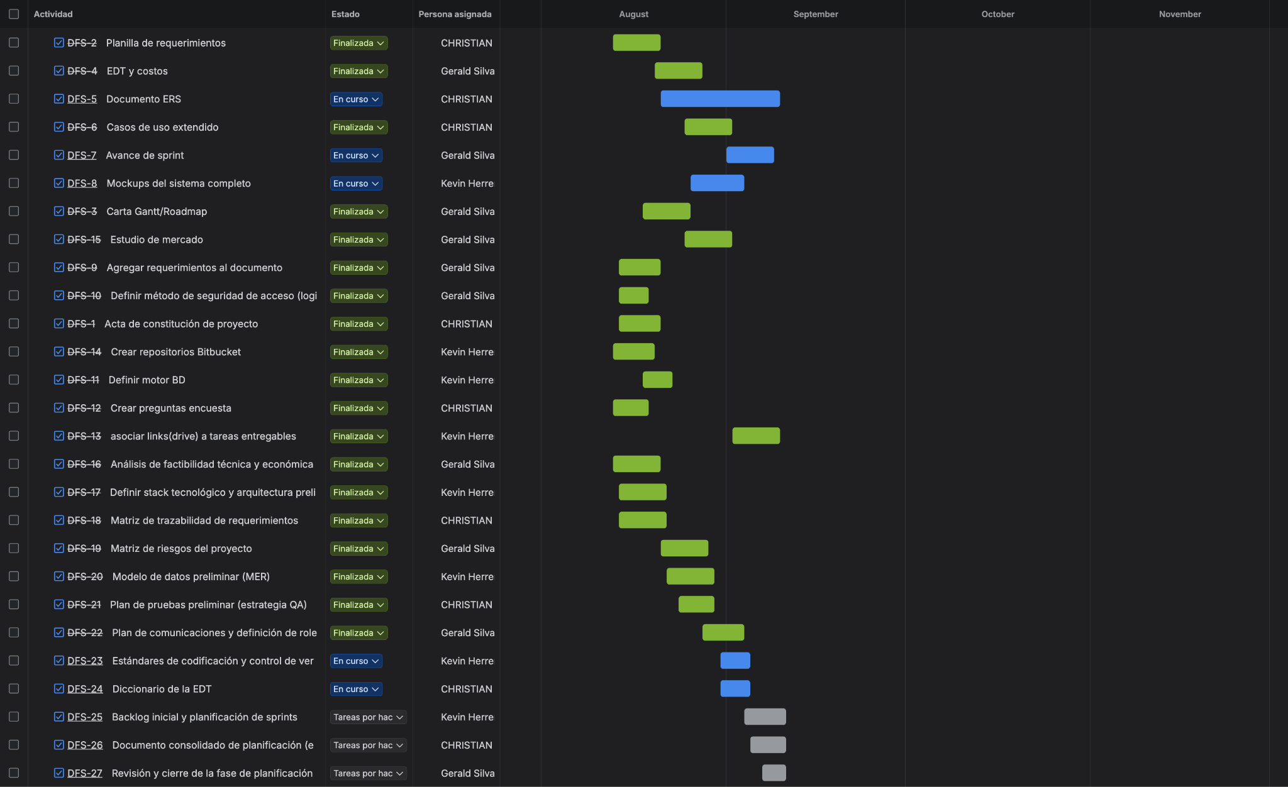

If the APT Project is a group project, this column must state the names of those responsible for each task or activity. This will later allow the assessment to be differentiated for each member.

